Add article in the ongoing replication setup (from Main-DB to SWSQL1)
Author | ​​Akshay Kumar Singh
Last Modified | ​​04/11/2024

Purpose:
This document will cover all the steps needed to add an article (table, SPs, views) in the existing replication setup from Main-db (Publisher at VacationExpress) to SWSQL1(Subscriber at Sunwing)
Publisher Server: main-db.vacationexpress.com
Subscriber Server: SWSQL1.Sunwing.local
Database Name: SoftripNetVE
Scope:
The below steps must be executed while handing request for adding article.
An example of such request is https://sunwing.freshservice.com/a/tickets/142130?current_tab=details.
Change Request created to track this activityhttps://sunwing.freshservice.com/itil/changes/6440#notes
However, before proceeding with the steps below, make sure we have required approvals in place and this activity will need a change request to be created and notify the requestors about this change date and time.
We need approvals from below stakeholders:
VacationExpress:
tphillips@vacationexpress.com and rmeeks@vacationexpress.com
Sunwing:
andrewbailey@sunwing.ca and Mrey@sunwing.ca
Process Execution:
- Connect to the subscriber server which is SWSQL1 in our case and check if the article that needs to be added already exists at the subscriber.
Use following query to check the same, we need to input the object name and publication name
USE SoftripNetVE; /* This is the database where the publication exists. */
SELECT DB_Name() PublicationDB
, sp.name AS PublicationName
, sp.status AS PublicationActive
, sa.name AS ArticleName
, o.name AS ObjectName
, srv.srvname AS SubscriberServerName
, s.dest_db AS SubscriberDBName
FROM dbo.syspublications sp
JOIN dbo.sysarticles sa ON sp.pubid = sa.pubid
LEFT OUTER JOIN dbo.syssubscriptions s ON sa.artid = s.artid
LEFT OUTER JOIN master.dbo.sysservers srv ON s.srvid = srv.srvid
JOIN sys.objects o ON sa.objid = o.object_id
Where sa.name like ‘%<give the object name>%’ and sp.name=<give the publication name>
order by PublicationName
- In our case, the table was already present at the subscriber however it was not a part of replication and hence having stale data. Rename the existing table at the subscriber (SWQL1) using sp_rename stored procedure, so that in the later stage snapshot agent must not fail stating “table already present with this name”
EXEC sp_rename ‘actual table name’, ’preferred table name’
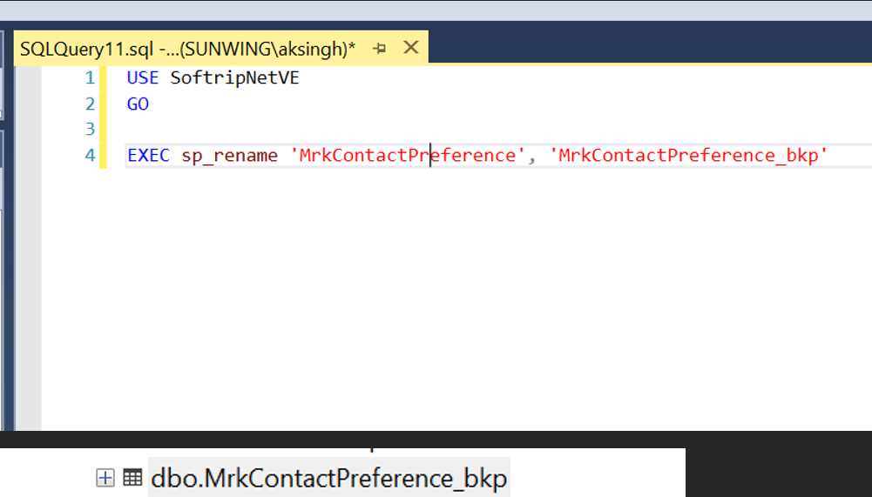
- Connect to Publisher database server Main-DB and check the status of the parameters namely “Immediate_Sync” and “Allow_Anonymous”. The expected values of these parameters would be 1 as shown in the below screenshot. If these values are 1, it means SQL replication will generate the snapshot for all the articles and initialize all of them, even if we are adding one article. We can use the below command to check this.

Use SoftripNetvE
go
sp_helppublication
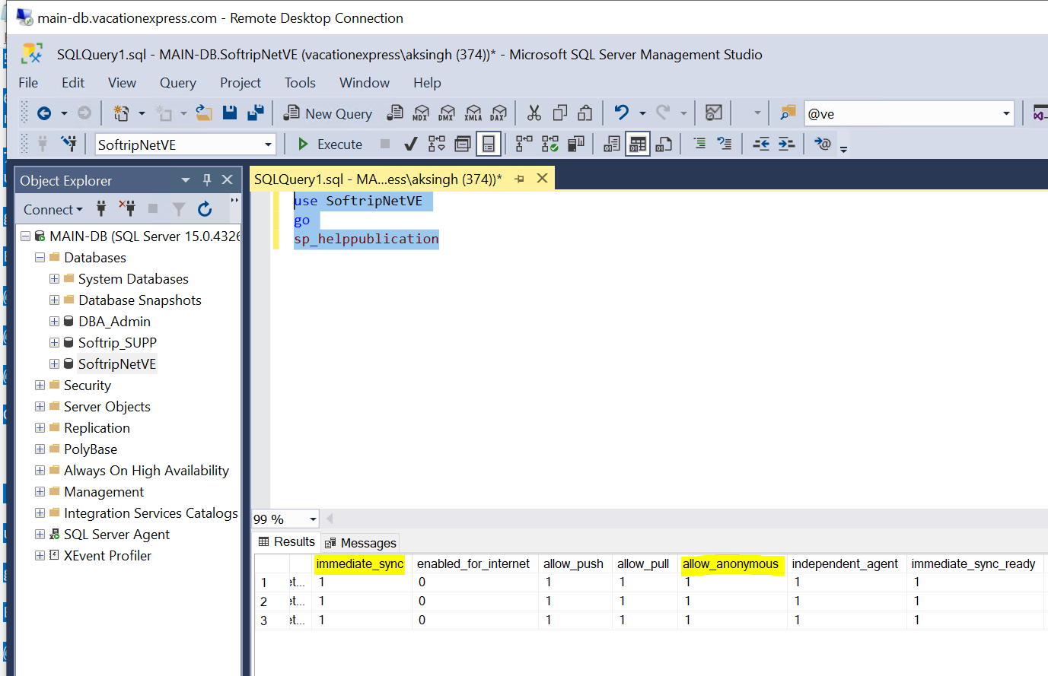
- However, we don’t want all the articles getting re-initialized at the subscriber just for the sake of adding one article. To achieve that, we need to set the parameters “Immediate_sync” and “Allow_Anonymous” to false (means 0)
--Set Allow_Anonymous to false for ATL_YYZ (Execute at Main-DB Server)
use SoftripNetVE
go
EXEC sp_changepublication
@publication = 'ATL_YYZ',
@property = 'allow_anonymous' ,
@value = 'false'
GO

--Set Immediate_Sync to false for ATL_YYZ (Execute at Main-DB Server)
use SoftripNetVE
go
EXEC sp_changepublication
@publication = 'ATL_YYZ',
@property = 'immediate_sync' ,
@value = 'false'
GO
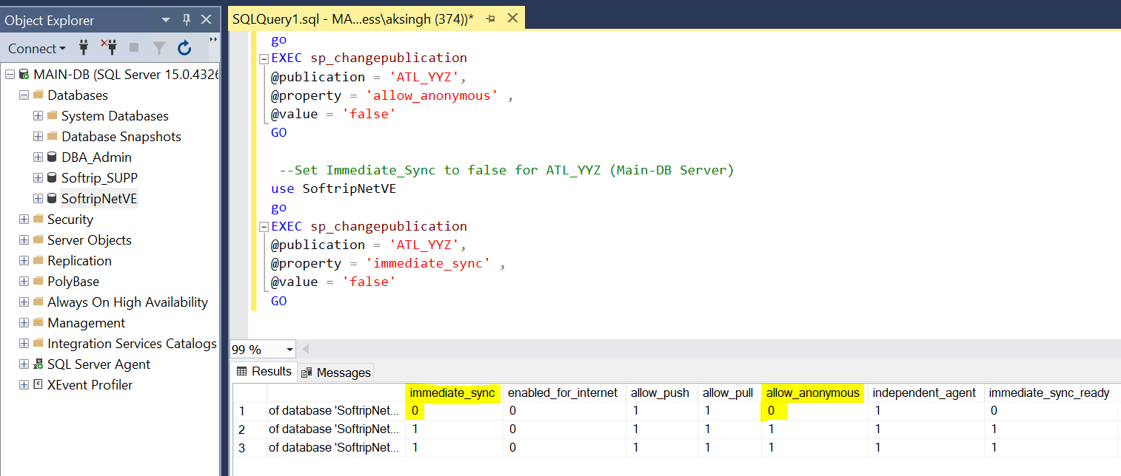
- Connect to Main-DB and expand the replication node and select the respective publication (which is ATL_YYZ in our case). ATL_YYZ is the publication getting published from Main-DB and getting subscribed at SWSQL1.
Choose properties for the ATL_YYZ publication.
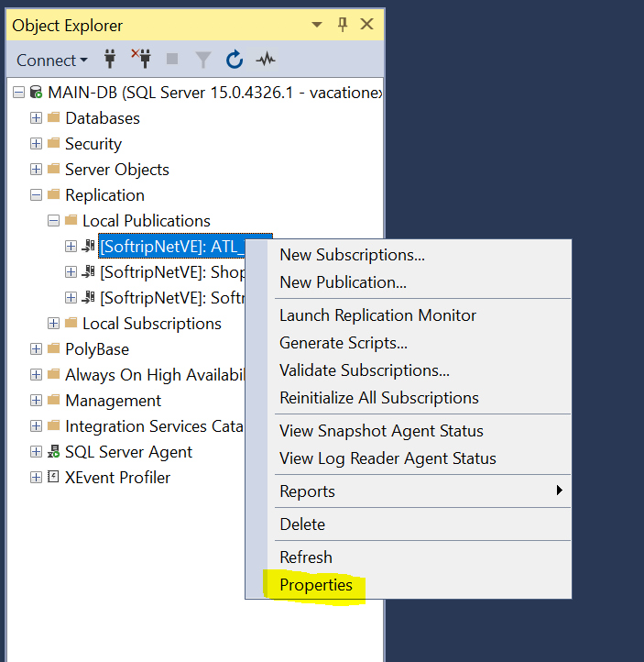
- The below window will prompt on our screen. Please uncheck the “Show only checked articles in the list” to see all the articles.
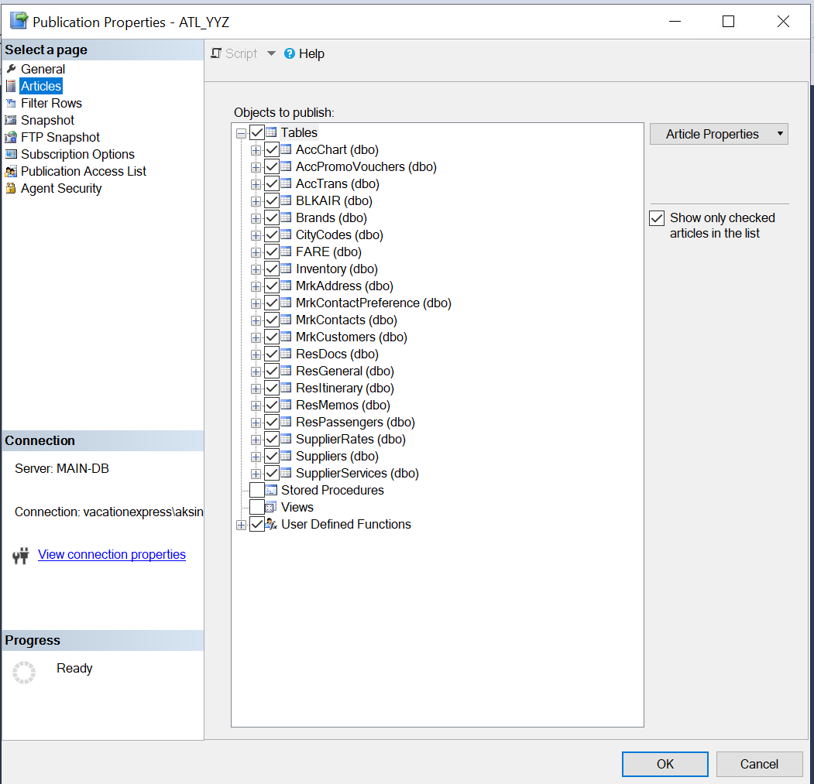
- Once unchecked, we will be able to see the full list of articles, however, will be able to add only those articles that have a primary key. Primary key columns are necessary for the tables in transactional replication. Select the table and click OK.
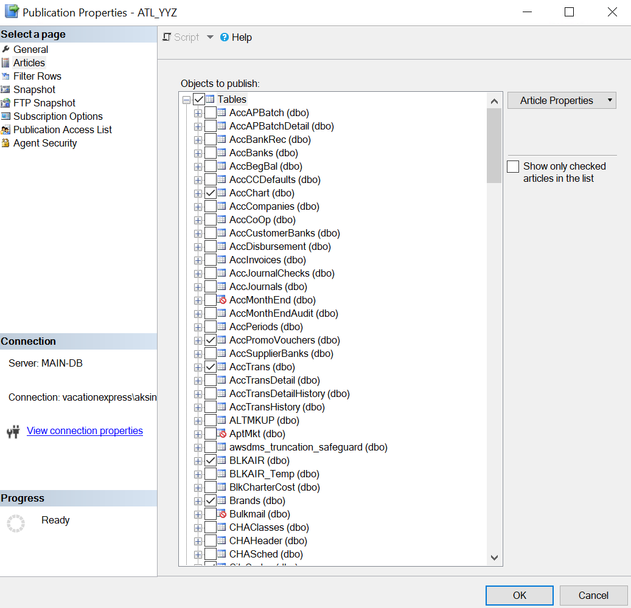

8. Run sp_helpsubscription on publisher database (SoftripNetVE) at Main-DB to verify the 'subscription status' of the subscribed article. It will be 1 (Subscribed).
0 = Inactive
1 = Subscribed
2=Active

- To make it active, we need to run the snapshot agent at Main-DB Server.
- Launch replication monitor at Main-DB.
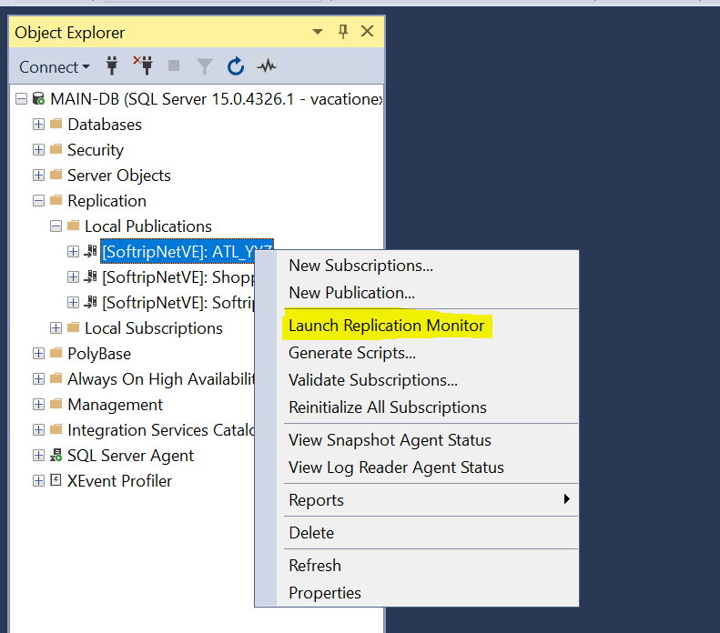
- Expand the Publisher from the left-side panel and select the respective publication (which is ATL_YYZ in our case) and click on agents as shown in the below screenshot
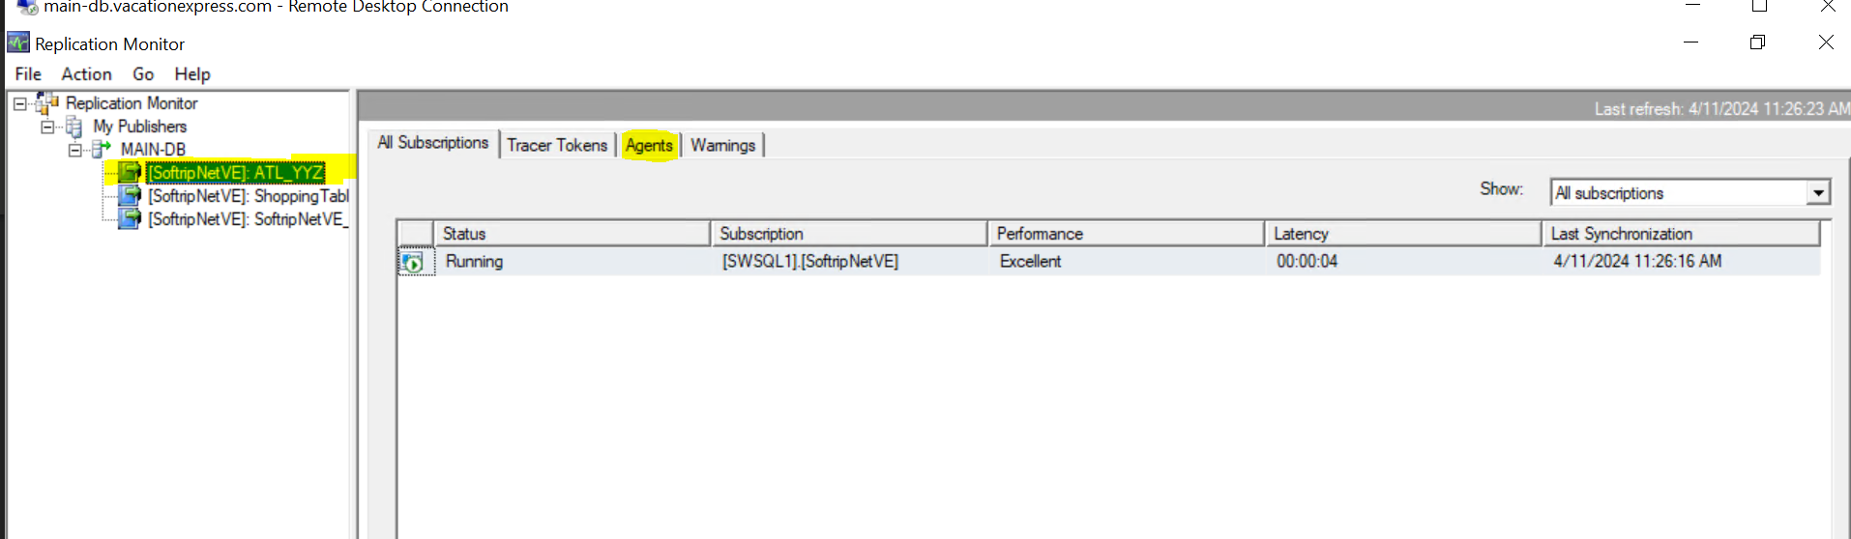
- Right click on the Snapshot agent and start it and we will see that it will generate the snapshot only for the added article (Snapshot of 1 article was generated). Please see the below screenshot.
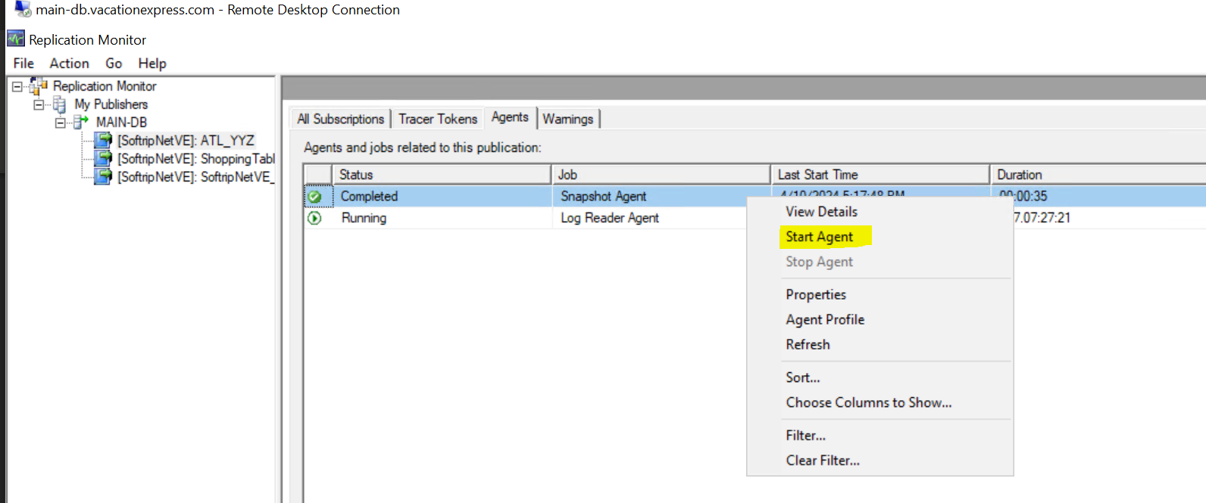
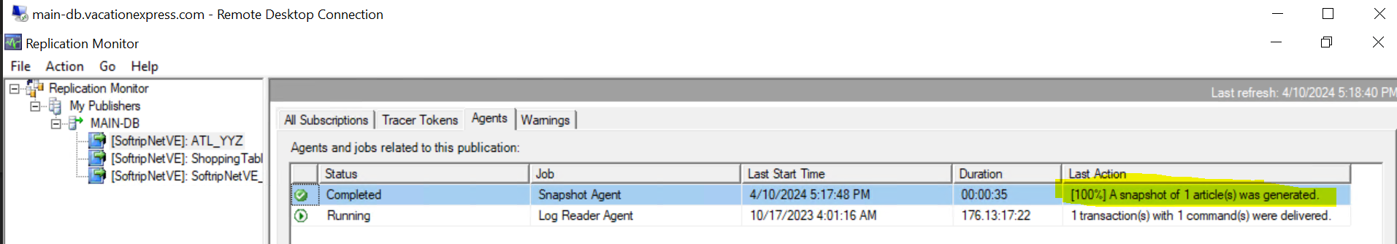
- We can verify the same by choosing “All Subscriptions” and right click and select to choose “view details”, we will be able to verify that the snapshot has been generated and applied to subscriber
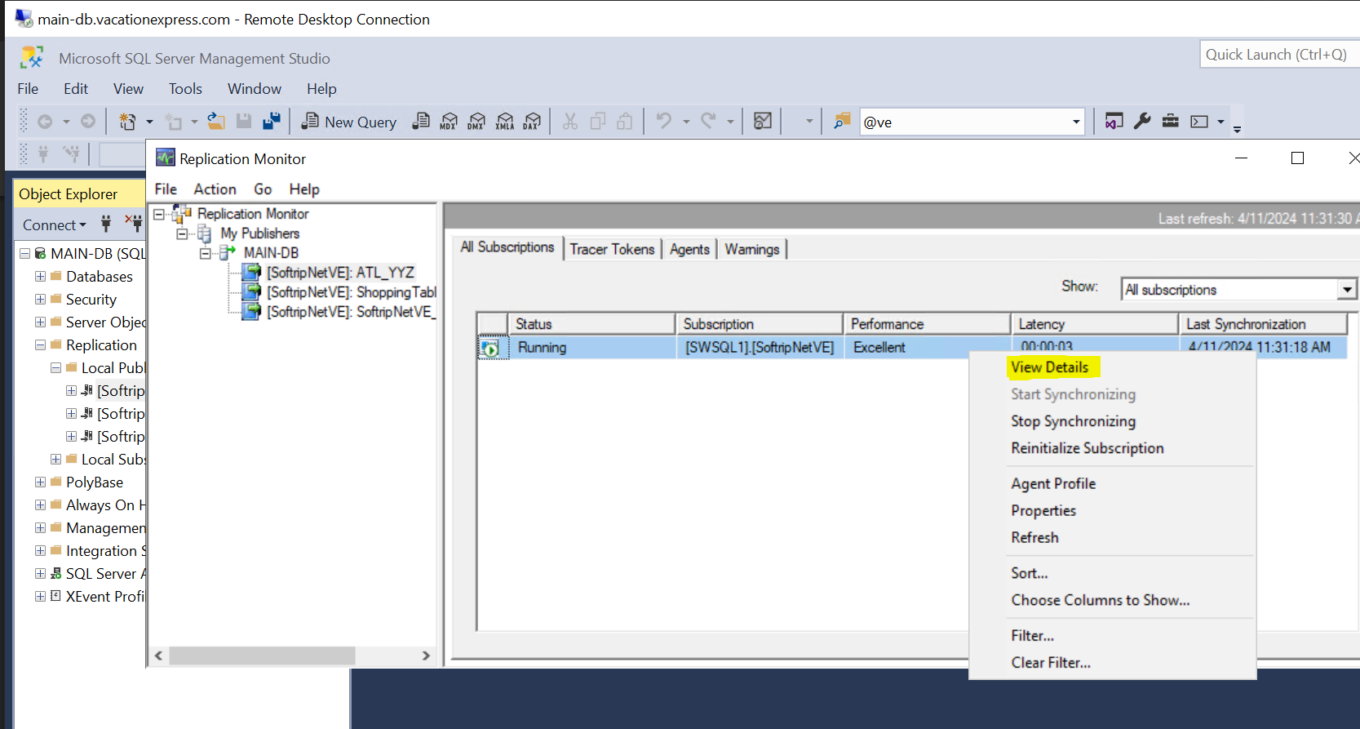
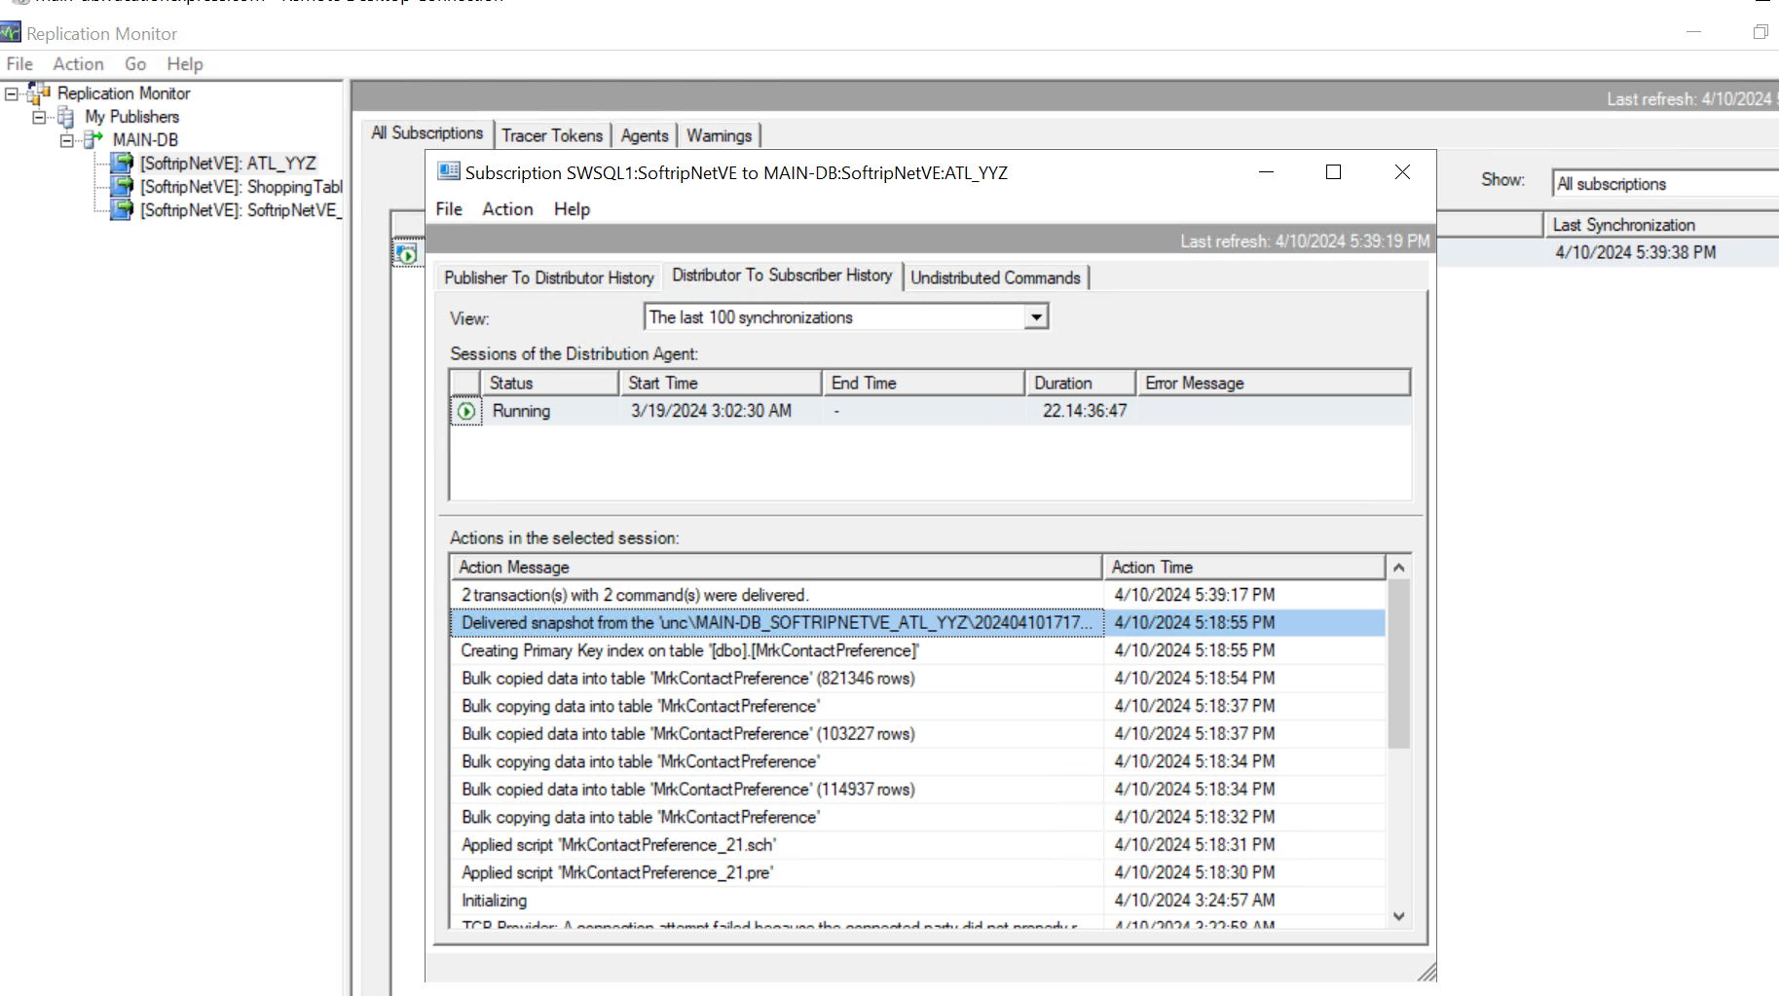
- We can check the newly added article by executing the following SQL query at the Main-DB Server
We need to input the object name and publication name
USE SoftripNetVE; /* This is the database where the publication exists. */
SELECT DB_Name() PublicationDB
, sp.name AS PublicationName
, sp.status AS PublicationActive
, sa.name AS ArticleName
, o.name AS ObjectName
, srv.srvname AS SubscriberServerName
, s.dest_db AS SubscriberDBName
FROM dbo.syspublications sp
JOIN dbo.sysarticles sa ON sp.pubid = sa.pubid
LEFT OUTER JOIN dbo.syssubscriptions s ON sa.artid = s.artid
LEFT OUTER JOIN master.dbo.sysservers srv ON s.srvid = srv.srvid
JOIN sys.objects o ON sa.objid = o.object_id
Where sa.name like ‘%<give the object name>%’ and sp.name=<give the publication name>
order by PublicationName
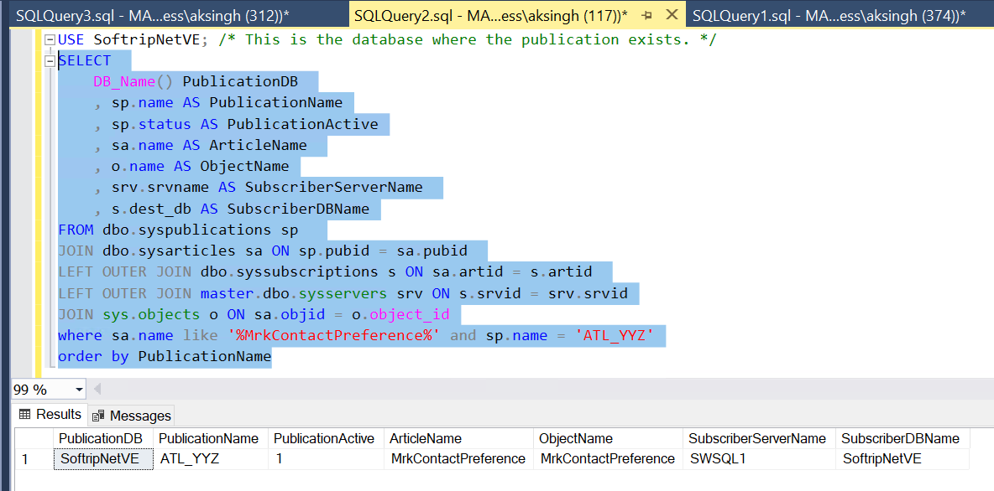
- Since we have verified that article has been added fine. Now, we can reset the parameters “Immediate_Sync” and “Allow_Anonymous” to True with the following queries.
--Set Allow_Anonymous to false for ATL_YYZ (Execute at Main-DB Server)
use SoftripNetVE
go
EXEC sp_changepublication
@publication = 'ATL_YYZ',
@property = 'allow_anonymous' ,
@value = 'true'
GO

--Set Immediate_Sync to false for ATL_YYZ (Execute at Main-DB Server)
use SoftripNetVE
go
EXEC sp_changepublication
@publication = 'ATL_YYZ',
@property = 'immediate_sync' ,
@value = 'true'
GO

